Logging into ECHOES as a Guest

[Echoes - Land Management](https://echoes-platform.eu/app/main/map-view)

2 Steps

Go to <https://echoes-platform.eu/>

1 – Login as a Guest

To login as a quest, rather than using any login credentials, you can do this by clicking on the 'Log in As Guest' button

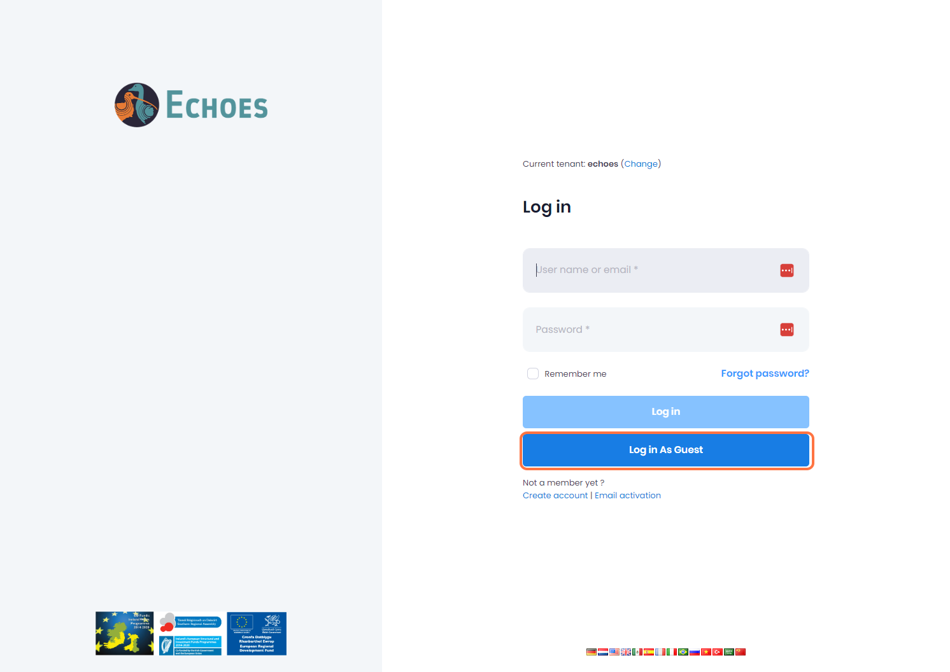

2 – Guest login differences

You will notice that there are only 2 sections available in the Guest Login, the Sites & Map View section. Anything created in the sites section will only be visible for this 1 session and not visible after a browser refresh.

